Bahria University,

Karachi Campus



LAB EXPERIMENT NO.

4

LIST OF TASKS

|  |  |
| --- | --- |
| **Task No** | **Objective** |
| 1 | Display Product Name and its Category Name where Category Name starts with B |
| 2 | Display Titles and their quantity |
| 3 | Use Right join to display Book Title and publisher Names. Write down the reason for any null values if coming in title column. |
| 4 | Use Right join to display those publishers where title is null |
| 5 | lists all customers and suppliers |
| 6 | Use cross join (Cartesian join) to Display Book Title and Publisher Name. |
| 7 | Use two full joins to Display Product Name, Category Name and Supplier Name |
| 8 | Use full join to display the name of Supplier for the product starting with letter C |
| 9 | Get shipper’s Company Name for an order using inner join. |
| 10 | Count no of Products’s against each suppliers name. list only those products whose count is greater than 3 |
| 11 | Display Region ID, Region Description, Territories Description and (inner join with table Territories and Region) |
| 12 | Display Company Name and Total orders placed by the company |

Submitted On:

5/4/2022

(Date: DD/MM/YY)

**Task# 01:- Display Product Name and its Category Name where Category Name starts with B**

**Query:-** select products.productname,categories.categoryname from products left join

categories on products.productid = categories.categoryid where products.productname like 'B%'

**Output:-**

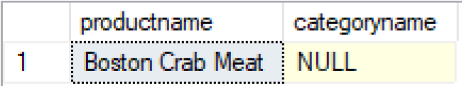

**Task # 02: Display Titles and their quantity**

**Query:-**

select titles.title,sales.qty from titles left join sales on titles.title_id = sales.title_id

**Output:-**

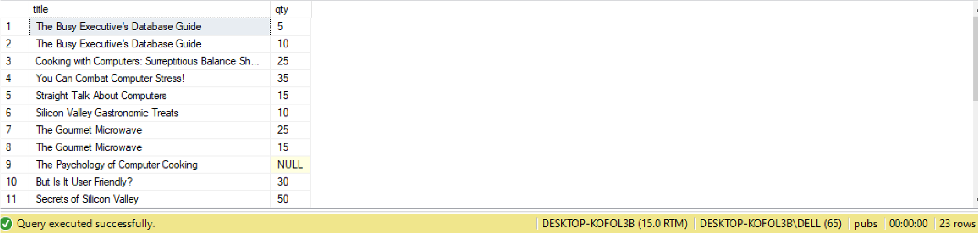

**Task#03:- Use Right join to display Book Title and publisher Names.** **Write down the reason for any null values if coming in title column.**

**Query:-**

select titles.title,publishers.pub_name from titles right join publishers on titles.pub_id = publishers.pub_id

**Output:-**

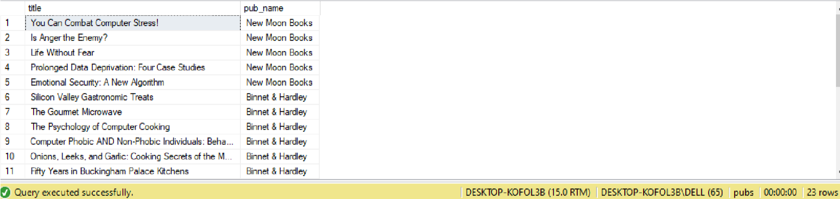

**Reason:-**

Null values are coming in title column because those publishers who do not have any book title, the title name for those publishers are null.

**Task# 04:- Use Right join to display those publishers where title is null**

**Query:-**

select publishers.pub_name from titles right join publishers on titles.pub_id = publishers.pub_id where titles.title is null

**Output:-**

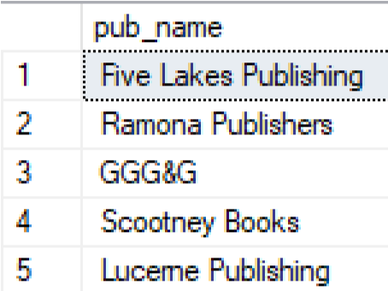

**Task# 05:- Lists all customers and suppliers**

**Query:-**

select t1.pub_name,t2.pub_name,t1.city from publishers t1,publishers t2 WHERE t1.pub_id <> t2.pub_id AND t1.City = t2.City

**Output:-**

No record found

**Task# 06:- Use cross join (Cartesian join) to Display Book Title and Publisher Name.**

**Query:-**

select t1.title,t2.pub_name from titles t1 cross join publishers t2

**Output:-**

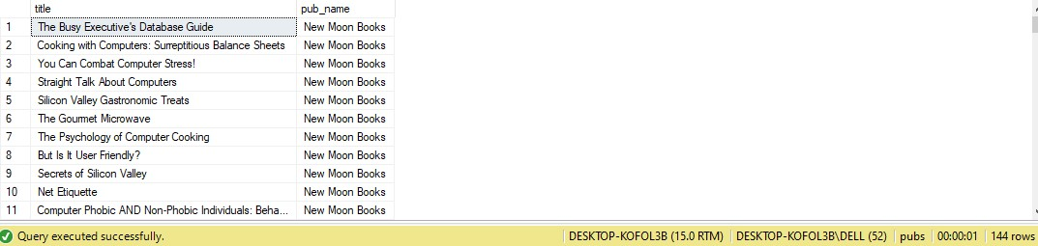

**Task# 07:- Use two full joins to Display Product Name, Category Name and Supplier Name**

**Query:-** select products.productname,categories.categoryname,suppliers.contactname from products full outer join categories on products.categoryid = categories.categoryid full outer join suppliers on products.supplierid = suppliers.SupplierID

**Output:-**

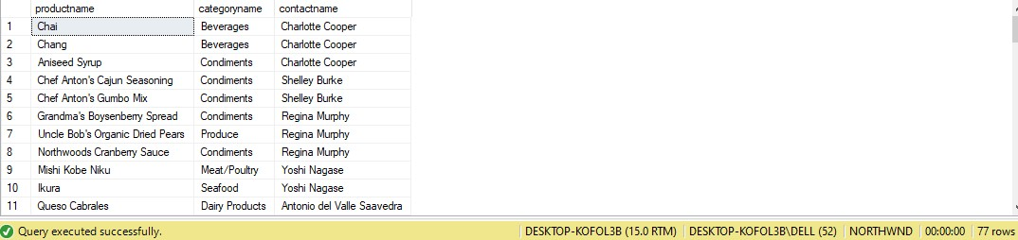

**Task #08:- Use full join to display the name of Supplier for the product starting with letter C**

**Query:-** select products.productname,suppliers.contactname from products full outer join suppliers on products.supplierid = suppliers.supplierid where products.productname like 'C%'

**Output:-**

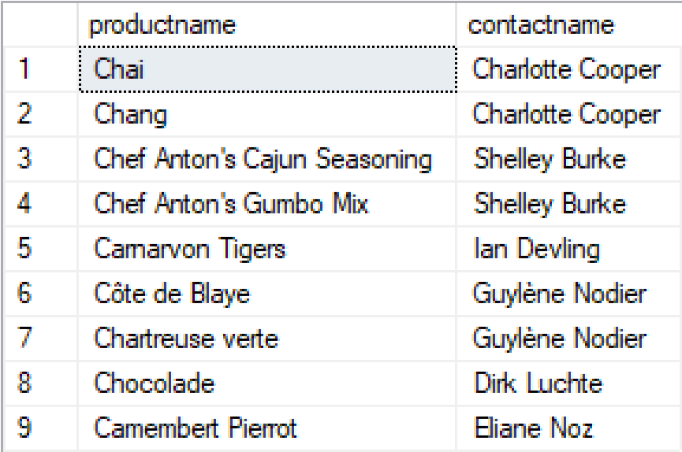

**Task**# **09:- Get shipper’s Company Name for an order using inner join.**

**Query:-**

select orders.orderid,shippers.companyName from shippers inner join orders on orders.shipvia = shippers.shipperid

**Output:-**

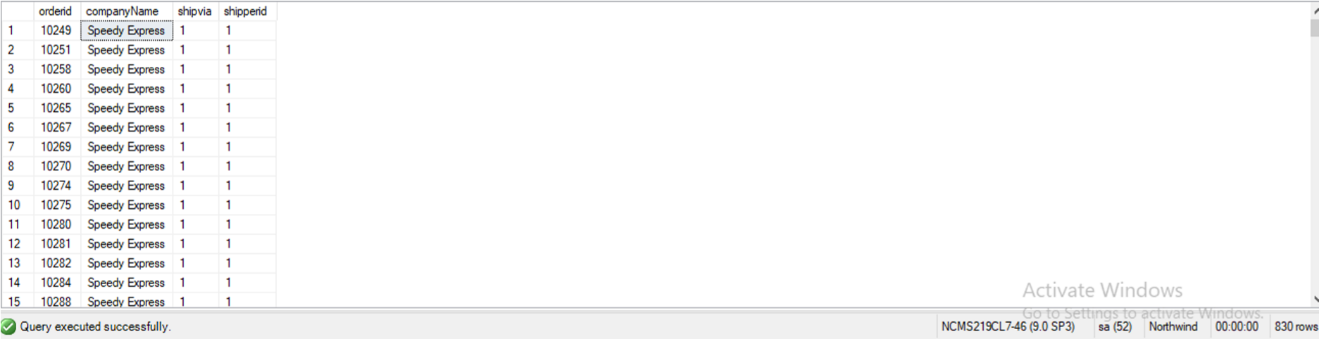

**Task# 10:- Count no of Products’s against each suppliers name. list only those products whose count is greater than 3**

**Query:-**

select suppliers.companyname,count(products.supplierid) from suppliers inner join products on suppliers.supplierid = products.supplierid group by suppliers.companyname having count(products.supplierid) > 3

**Output:-**

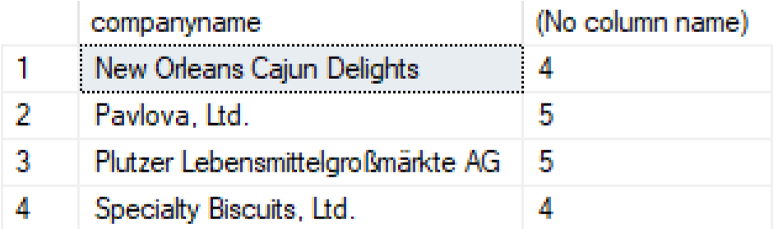

**Task# 11:- Display Region ID, Region Description, Territories Description and (inner join with table Territories and Region)**

**Query:-**

select region.regionid,region.regiondescription,territories.territorydescription from region inner join territories on region.regionid = territories.regionid

**Output:-**

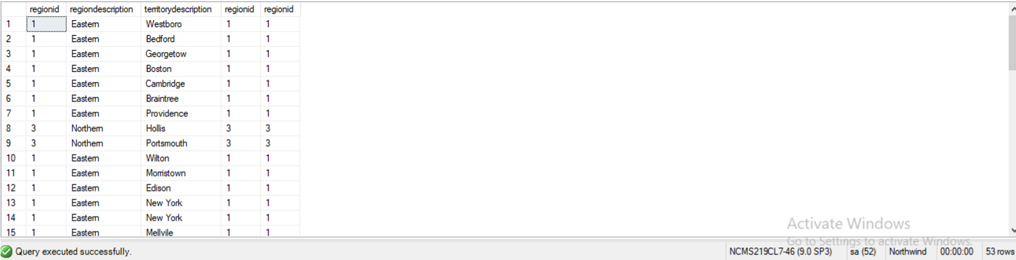

**Task# 12:- Display Company Name and Total orders placed by the company**

**Query:-**

select customers.companyname,count(orders.customerid) from customers inner join orders on customers.customerid = orders.customerid group by customers.companyname

Output:-

